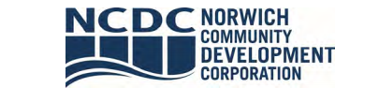
Board of Directors Meeting

AGENDA
Thursday, September 26, 2024, 8:00 am
Foundry 66 – First Floor Large Conference Room

Via Zoom: https://us02web.zoom.us/j/83861277740?pwd=cUdrOFdBWmR6SHFVNjJ5UDRzVEFKUT09

1. Call to Order and Establishment of Quorum

2. Approval of the Minutes from the Board Meeting on August 29, 2024

3. President’s Report
a. Resolution: Brownfield Remediation grant application support
b. NRP Dashboard Review

4. Foundry 66 Update

5. Global City Norwich Update

6. Downtown Development Update

7. Treasurer’s Report
a. Financials

8. Executive Session
a. Real Estate Matters

9. Adjournment

10. Post Meeting Site Visit at Reid & Hughes – Progress Update

Next Board of Directors Meeting: October 24, 2024, 8:00 am

