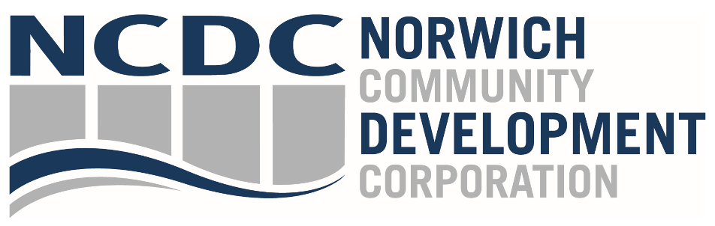
Meeting Minutes
8/22/24
Meeting called to order at 8:10 am. Quorum established.
Present:
Becka Alberts, Chairwoman Chris Jewell, Vice Chairman
John Mancini, Treasurer Mayor Peter Nystrom
Swarnjit Singh Angelina Gardiner
Chris LaRose J.P. Mereen
Lynn Perry Benjamin Green
Brian Hayes Sheila Hayes
John Salamone

In Attendance:
Kevin Brown, President, NCDC Devin Schleidt, Consultant
Mary Riley, Community Manager, Foundry 66 Bobbie Braboy, Director, GCN
Lucas Kaiser, Community Development Specialist Mark Block

JP Mereen made motion to approve the minutes from June meeting. John Salamone seconded motion. Motion passed.
President Report
Kevin Brown states Norwich Revitalization Program now closed with final business review board complete. 19 awards to date. $3.5M spend met before federal deadline. 7 special projects at $2M also ahead of schedule. Scott Lessard reported in detail about final business review board, payments completed and scheduled, project status updates, and square footage activated – 468K square feet. Hayes inquired about art spend spreadsheet presented by Lessard. Concerns of over-subscription. Lessard explained certain projects will drop off the list and financial obligations will remain in a positive position.
Brown reported an LOI signed with major tenant for OIC. Brown also stated the need to secure construction management firm for the imminent roadway construction. Plans are for mid-September to put together RFP due by end of October.
Brown gave updates on state of the cannabis industry in Norwich. 5 cultivators are currently engaged at various levels of interest. Continued efforts from cannabis licensees include Social Equity and Workforce Development plans. Cannabis sales tax has exceeded initial tiered projections. Review of actual versus projected.
The Mercantile is currently under its 3rd extension with MPTN. DECD is circulating release for signatures. September target due to vacations and cultural celebrations. Delays in this thread include parking garage ownership and control. Do we keep or let it go? Long term strategy should be considered.
Brown communicated the status of CIF applications for the Waterfront and Capehart Mill. Final recommendations for awards are in review at DECD with announcements scheduled for September 10. Agenda is typically published mid-week.
Capehart financial plan being completed by Brian Long and Deanna Rhodes with support from NCDC.
Sheila Hayes asked about the restaurant at the Marina. No funds had been awarded in previous round for the restaurant. Current application, different round, does have flex for infrastructure.
Reid & Hughes is in process with lift in place for window work. $184k in payouts from ARP and $550k in CIF funding with final draw soon. Tax fixing structure plan to be developed for this and future projects.
Lower Broadway and the Urban Act Grant is in progress with Newman Architects selected as the provider for construction documents. Planning meetings to begin.
Thermos was awarded $2.8M in brownfield remediation for the removal of glass factory. A solar field installation a condition of grant. Issuing RFP for an Engineering Assessment of the site is the pending step.
Envision Norwich 360 renewed for 6 months, supporting both continued CIF 2030 public engagement and future engagement regarding Zoning Regulation review by Director, Planning & Neighborhood Servies.
Questions & Comments
Salamone: Commented on editorial from Bill Kenney. He stated a need for an overhaul of messaging and imaging; needs sustainable solution.
S. Hayes: Worried about starting and stopping – a common occurrence in Norwich.
Brown: Potentially handled by team recalibration
Salamone: Will be in the budget for 25/26
Foundry Report:
Mary Riley completed the monthly Foundry 66 report. Seasonal fluctuations in play. Pipeline of new members for September and this month was a wash. Revenue remains at 79% of target. Events returning next month.
Global City Norwich
Bobbie Brayboy provided an update on events. The Jamaican flag raising hosted 30 people with food provided by Milton’s Jerk Hub. Working on an international food partnership. Accelerator check received. Continuing to work with Foundry 66 on Working Lab 3.0. Applying for Sachem Fund to support program goals.
Downtown Update:
Lucas Kaiser spoke about parklet installations, AARP grant application, and continued Lower Broadway efforts.
Finances:
Devin Scheidt presented on the most recent financials. Foundry ahead of projected loss by $80K. NCDC slightly behind budget by $49K due to timing of check receipts. Salamone asked for a report on grant lag. Schleidt to email.
Peter Nystrom made motion to accept financials. Hayes seconded. Motion passed.
Schleidt also reported on credit card controls with Brown including intent behind decision is to separate cards for better security and reduction of administrative burden.
Schleidt reported on money market rates and recommended keeping funds at Chelsea Groton Bank due to ease of operations and existing relationship.
Mereen made motion to continue with Chelsea Groton for the money market account. Seconded by S. Hayes. Mancini abstained. Motion passes.
Nystrom made motion to enter Executive Session at 9:42. Singh seconded.

